Project Wiki

# Wiki Pages

The project wiki is used to document the details and progress of the project. Each page will be designated for different topics. This will include the program requirements, project tasks, personal/team tasks, and acceptance test records. More information may be tracked if deemed necessary.

## Main Page

The main page provides a summary of the project and a list of planned features for each iteration of the project.

## Tasks

The task page contains all tasks designated to team members by the project manager (Janelle).

### Adding a Task



To add a task, click the box marked in red as shown above. Write a text description of the task and use the ‘@’ symbol to tag the team member that the task will be designated to. To add a date to the task, type two forward slashes ‘//’ and choose the appropriate date.

## Task Reports

There are task report pages for each team (Development, Testing, Build, and Triage). The task report gathers all tasks specified to any member of the team’s page and displays them into two lists, complete and incomplete. These reports can be sorted by date or who they are assigned to.

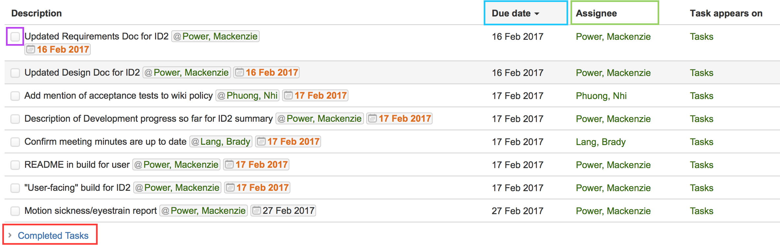

Once you have completed a task, the task can be marked completed where the purple box above indicates. After the task has been marked completed. The task will then be moved to the “Completed Tasks” list as shown in the red box.



To sort the tasks, you can either clicked on the “Due Date” or “Assignee” marked in the blue and green boxes above.

## Acceptance Test Records

This page will contain a table to keep track of Acceptance Tests. This table stores accounts of the manual Acceptance Tests performed to date on the software, confirming whether the software performs desired functions from a user's perspective.

Possible reasons for performing acceptance tests:

* **Feature** - A developer has worked on a new feature that affects some or all of the functionality being tested
* **Merge** - A feature branch has been merged into the "development" branch
* **Freeze** - Testers will perform acceptance tests after a development freeze to determine if any issues remain to be fixed for a deliverable.
* **Fix** - A developer or tester will perform after changes were made to fix one or more failing tests
* **Deliverable** - The project manager will test whether the software is conforming to requirements prior to a deliverable.

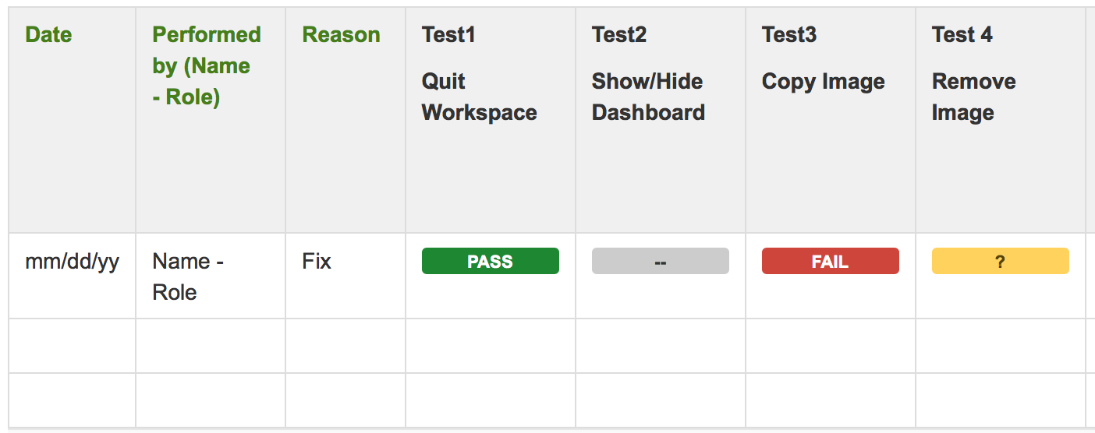

The above image shows an example of how to fill out the table. Each test will be labeled with a colored box indicating the result of the test.

Each box is explained as follows:

|  |  |
| --- | --- |
|  | Indicates the test has passed |
|  | Indicates the test has failed |
|  | Indicates that the results are inconclusive |
|  | Indicates the test was not attemped |

# Pages to Implement

These are pages that still need to be implemented if the team deems it necessary.

## Team Pages

Each team will create a page to post important information in regards to procedures and policies. Each team should create their own page, choosing the template that they believe would best fit the information it will hold. With the team members moving positions and helping in different areas, it is best to keep all members updated.

## Requirements

A “Product Requirements” page can be used to keep track of the decided upon requirements for this project. This page contains a template that will be filled out. This page can be updated with any changes as the project progresses.

## Meeting Minutes

There are there different templates for meeting minutes. This can be discussed to decide upon which template fits our needs.

## Oher

There are many other templates to use. We can discuss as a team if these other options are important. Other pages may include: blog posts (any updates), decisions (record important project decisions and communicate them with the team), content sharing, JIRA reports, charts, etc.

# Policies

All changes* to page content should be done by the project manager or team leads. Team leads shall only edit their team page. If there are any concerns about content on another team’s page, the appropriate team lead will be notified.

*\*excludes marking a task as completed*